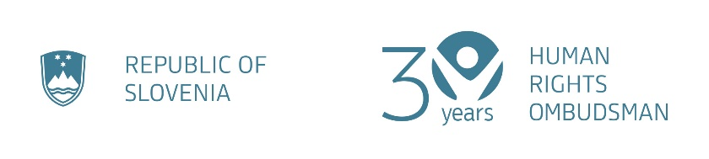

Speech delivered by Deputy Human Rights Ombudsman of the Republic of Slovenia,
Dr. Jože Ruparčič at the reception marking Human Rights Day,
Ljubljana, 10 December 2025

Dear Distinguished Guests,

Good evening – on behalf of myself and on behalf of this evening's co-hosts – Deputy Ombudsman Dr Dijana Možina Zupanc and Deputy Ombudsman Miha Horvat, as well as Deputy Ombudsman Ivan Šelih, who unfortunately is unable to be here with us this evening.

Today I have the honour to speak to you on behalf of all of us.

For the first time in the history of our institution, a Deputy Ombudsman is doing this on Human Rights Day.

Someone else should be standing at this podium today – the Human Rights Ombudsman. That is why there is an empty chair on this stage.

This void speaks for itself. It speaks of a person with a full mandate and a legitimate position at the head of an institution that was established to protect the rights of all people. It speaks of a person who do we not have.

The institution of the Human Rights Ombudsman of the Republic of Slovenia has been without a head for almost one year.

This is not just of organisational or protocol concern.
This is not just a question of personnel or procedures.
This is a message.

The message that human rights can be marginalised – even at the highest state level.
That in a country that speaks highly of them, they can, in practice, become a second-class issue.

During these months, when we Deputy Ombudsmen have been leading the institution, we –and our colleagues – have tried our best.
With great dedication and responsibility, we bear the burden of protecting what is most precious: the dignity of people.

This year is, and has been, challenging.
Without the right support, even enthusiasm and passion quickly fade.
But we persevere – because we believe that the Human Rights Ombudsman is more than a function, more than a job, more than an institution.
It is a mission.

The very word VARUH speaks for itself. If we play for a moment with the letters that make up the word, its meaning becomes even pertinent.

- V is for voice – to speak out when power fails.
- A is for accountability – the daily work to ensure that human rights do not become empty letters on paper.
- R is for refuge – that no one is left unprotected when their voice is not heard.
- U is for understanding – that we hear the most vulnerable, even when others look the other way.
- H is for hope – that there is someone who fights for them, even through the hardest times.

Ladies and gentlemen,

This is VARUH - the OMBUDSMAN.
It is not and should not be an afterthought.
The Ombudsman is the foundation of democracy and the rule of law.

When human rights become marginalised, people affected by injustice also become marginalised.
And we as a society cannot permit this to happen.

That is why today we are making an appeal to decision-makers:
Make sure that the institution of the Human Rights Ombudsman is not an empty shell without real leadership.

Make sure that human rights are not merely a promise, but an actual practice. And demonstrate it.

We believe that we can replace old approaches with new ones. And also with the courage that demands answers and responsibility, regardless of the pressure and criticism we may face.

Just like the courage we had to muster to send this message today.

Thank you.

